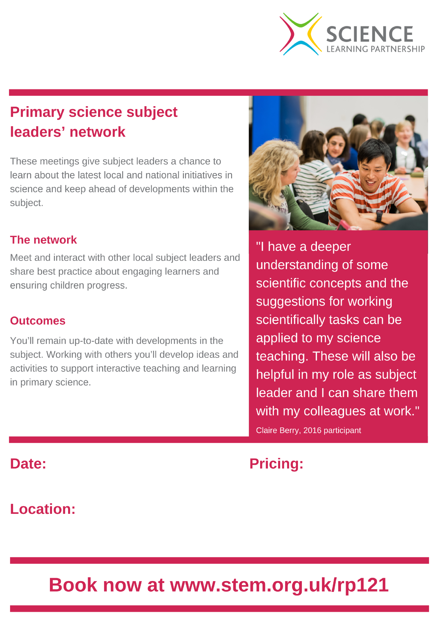



**Kate Penarski**

**Primary Hub Lead**

**slp@gmslp.co.uk**

**For further information and to book please follow the link:** [**https://www.stem.org.uk/cpd/485971/subscription-bolton-primary-science-network**](https://www.stem.org.uk/cpd/485971/subscription-bolton-primary-science-network)

**Only £400 for whole school full membership.**

**Remote via Adobe**

**This includes: three Subject Leader Network Meetings PLUS five key stage-specific CPD Network sessions that multiple staff from your school can attend.**

**Greater Manchester Science Learning Partnership Bolton Science Subject Leaders Network**

2ndt December 2020 3.45 - 5.00 14th April 2021 3.45 - 5.00 13th January 2021 3.45- 5.00 19th May 2021 3.45 -5.00

10th February 2021 3.45 - 5.00 16th June 2021 3.45 - 5.00

3rd March 2021 3.45 - 5.00 14th July 2021 3.45 - 5.00

