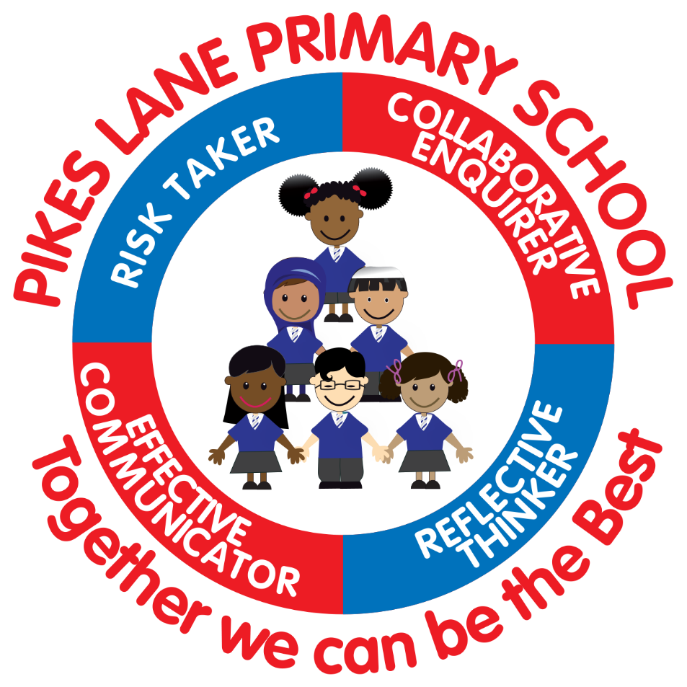

Policy Leader: N Wiggans

Link to Governor Committee:
Curriculum, Standards and Wellbeing

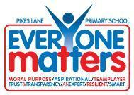

Curriculum Intent
At Pikes Lane, we believe that a quality English curriculum should develop children’s love of reading, writing and discussion. We aim to inspire an appreciation of our rich and varied literary heritage whilst cultivating a habit of reading widely and often. With the use of carefully chosen texts (fiction, non-fiction and poetry), we aim to support our children’s developing knowledge and understanding of the world around them and expose them to a wide range of cultures, both past and present.

We want our pupils to be heard, both orally and through the written word. Our aim is for our children to become confident orators who, using a wide range of vocabulary, can use discussion to communicate their thoughts, ideas and opinions. We nurture a culture where children: take pride in their writing, can write clearly and accurately and adapt their language and style to suit a range of purposes and audiences.

We aim to support our pupils to develop a secure knowledge-base in English, which follows a clear pathway of progression as they advance through the primary curriculum. We believe that a secure basis in English skills is crucial to a high-quality education and will give our children the tools to follow their dreams and achieve their aspirations.

At Pikes Lane we strive to ensure that our pupils:
- read and write with confidence, fluency and understanding;
- are able to draw on a full range of reading cues to decode text and correct their own mistakes;
- develop a lifelong interest in books, read with enjoyment and evaluate and justify preferences;
- understand and use a range of text types and genres for a wide-range of purposes;
- appreciate the rich literary heritage of the English language;
- have an interest in words and their meanings and develop a growing vocabulary in written and spoken forms;
- become confident communicators of ideas, opinions and preferences;
- understand how to use phonetics; word recognition processes; etymology and morphology to read and spell accurately;
- have fluent and legible handwriting;
- develop skill the skills to plan, draft and edit their own writing, and the writing of others;
- have a suitable technical vocabulary to understand and articulate responses to their reading and writing;
- develop their powers of imagination, inventiveness and critical awareness though reading and writing.

STATUTORY REQUIREMENTS
Statutory requirements for the teaching and learning of English are laid out in the National Curriculum English document (2014) and in the Communication, language and literacy section of the Early Learning Goals.

IMPLEMENTATION

APPROACHES TO TEACHING AND LEARNING

ORACY
Teaching staff ensure that opportunities for speaking and listening permeate the whole school curriculum. Pupils are supported to clarify their thinking and organise their ideas for writing and articulate their responses as they are taught to:
- Speak clearly and convey ideas confidently using Standard English
- Justify their idea with reasons
- Ask questions to check understanding
- Develop and extend their vocabulary with use of: carefully chosen tier 2 word suitable to genre; knowledge mats; use of morphology (inline with vocabulary frame expectation)
- Choose vocabulary, intonation and expression that is suitable for the task/ situation
- Negotiate
- Actively listen to the ideas of others
- Evaluate and build on the ideas of others
- Give well-structured descriptions and explanations
- Develop their understanding through speculating, hypothesising and exploring ideas.

Specific practice may include:
- Collaborative learning structures
- Participation in structured group and class discussions
- Listening, reciting and responding to rhymes, poems, songs, stories and non- fiction
- Role play
- Drama
- Use of visual stimulus to prompt discussion
- Wow/ hook activities
- First- hand experiences to support development of vocabulary in context.
- Reading aloud
- Knowledge mats
- Debate
- Peer editing
- Talk for writing
- Oral rehearsal of writing
- Socratic Seminars
- Participation in assemblies/ shows
- Use of 6 ps: passion, pace, pitch, punctuation, pause, power to support the delivery of speeches.

Non-negotiables:

At Pikes Lane pupils have the opportunity to take part in two carefully planned speaking and listening opportunities as part of wider curriculum learning. This is evidenced on Earwig (#oracy).

READING
At Pikes Lane, we recognise the vital role reading plays in supporting children to develop their imagination and how the enjoyment of reading can fire the curiosity within a child’s mind. Reading is an effective vehicle to support pupils to: acquire new knowledge; build upon prior knowledge and make links with the world around them. Fiction and non-fiction reading spines are evolving to support children to deepen their understanding of the wider curriculum.

At Pikes Lane our understanding of reading is shaped by the research of Dame Marie Clay.
“Reading is a message-getting, problem solving activity that increases in power and flexibility the more it is practised.”

Consequently, all teachers of reading at Pikes Lane aim to make the ‘invisible process’ of reading visible through the use of carefully planned, effective modelling. Pikes Lane reading symbols are displayed in classrooms and are referred to by staff to reinforce the range of reading skills used both within English sessions and across the curriculum.
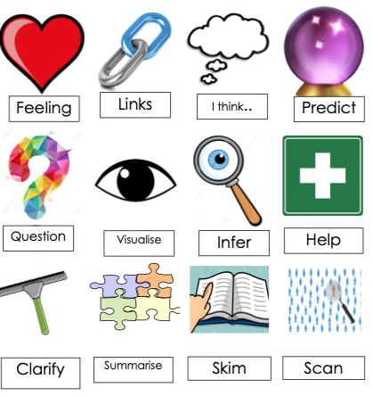

Pikes Lane reading symbols, training notes and prompt questions to support development of active reading skills can be found:
https://drive.google.com/drive/folders/1evg3S-Tg-jiOHYRlZyakYGShfEl9Wn-G

We understand that in order for pupils to become proficient readers, they must develop 5 key reading skills known as The Big Five.
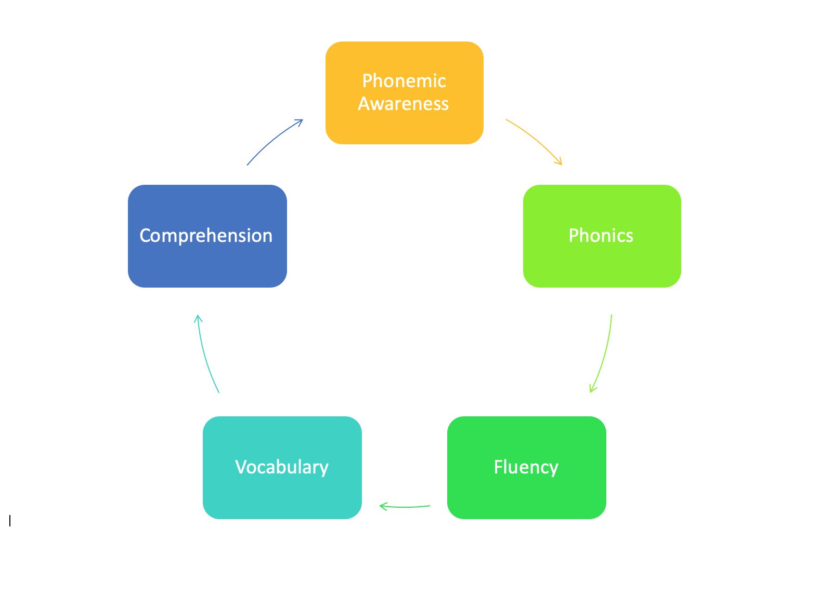

At Pikes Lane, the big five to be:

- Phonemic awareness: understanding individual sounds in individual words (see phonics policy)
- Phonics and decoding: reading sounds and words (see phonics policy)
- Fluency: pupils read in phrases
- Vocabulary: words that the reader understands (see vocabulary policy)
- Comprehension: meaning made by text (use of active reading strategies)

Staff also recognise the importance of supporting pupils to develop word reading processes.
Pupils are encouraged to:
Self-Monitor: notice their own ‘breakdown’ in understanding. This may be a gap in phonemic knowledge or a gap in vocabulary/ context.
Staff Deliberate Instruction:
Notice where pupils have made a mismatch with words and meaning
Value the partially known - question pupils as to what the pupil can see, encourage use of phoneme/ root word/ context as necessary to support pupils to ‘solve the problem’

Teach cross checking behaviours: identify that something is wrong in meaning
- Does it make sense?
- Does it sound right?
- Do the words match the letters on the page?
- Read word in context of the sentences
- Can children identify which part of the text is the ‘tricky part’?

Once pupils are efficient in cross-checking behaviours, they will be able to self-correct (correct their own mistakes).

Early Reading (EYFS)
At Pikes Lane, we recognise the vital role that listening to adults read has on igniting the pupils’ curiosity to understand the print around them. Staff share books with our pupils widely and often.

In order to support the pupils in making sense of print, staff carefully observe children whilst they are engaging with print and overtly model ‘print awareness’ (putting the messages we want others to read in print) and directional rules.

Teachers model through a range of activities in a number of contexts:
- That print carries a message (not the picture)
- Left to right directionality
- Finding the first and last letters of a word
- Why spaces lie between words
- Word-by-word matching
- Use of punctuation

Once children have word-by-word correspondence, staff should support children to track the words across the page without the use of a finger. Children should then be taught to read in phrases.

We recognise the vital role phonics plays in enabling children to make sense of print. Please see the phonics policy for further detail.

Reading at KS1 and KS2
Teaching staff work hard to promote a love of reading and encourage pupils to read widely. Pupils read daily in class in guided reading sessions or as part of the English teaching sequence. Each class has its own reading corner which is stocked with age-applicate fiction and non-fiction texts, supplemented by termly loans from the local authority library service.

Pupils enjoy high-quality whole texts (both fiction and non-fiction) through English lessons and the wider curriculum. They are taught to read fluently and understand a wide range of texts through:

Specific practice includes:
- Weekly 1:1 reading session for every child in year 1. Targeted children in Y2 - Y6 have 1:1 reading weekly.
- Regular reading of class novel
- Daily phonics sessions for pupils in EYFS and KS1(and Y3 Covid 2021/22)
- Phonics sessions for target pupils in Key Stage 2 (those who did not pass phonics screening test at the end of KS1 and pupils with EAL or specific needs)https://drive.google.com/drive/folders/1_Vzx-kVizg2JPy-LDxk3TsrZ_6JCz0C8
- Modelling the use of segmenting and blending (finding start and end of words) progressing to reading in phrases as children develop as readers.
- Modelling of appropriate use of punctuation (pausing at boundaries) as this is where meaning is made
- Modelling rhythm, intonation, expression, pace
- Modelling Active Reading Strategies (making reading visible) with the use of Pikes Lane reading symbols
- Modelling specifics and precise responses to comprehension questions including ensuring that pronouns are not used within responses. Pupils must be encouraged to use the proper nouns for precision.
- Overt modelling use of active reading strategies (predict, clarify, inference, summarise, break down strategies, visualisation) in English lessons, reading sessions and across the curriculum.
- Using AfL to plan questions to address content domains
- Exposure to a wide-range of quality literature
- Planned opportunities for independent, paired and shared reading
- Regular written comprehension activities (Y2 to Y6).
- Opportunities to apply reading across the breadth of the curriculum
- High-profile reading opportunities within the writing teaching sequence
- Use of Non-fiction reading spine to take age-appropriate reading into all areas of the curriculum
- Use of ICT to support reading: audiobooks, Borrow Box, Reading Realm, Rising Stars ----- Staff to exert caution when using online reading resources as research suggests that on screen reading is a different reading experience ( Delgato et al 2018: Don’t throw away printed books: meta-analysis on the effectiveness of reading media on comprehension)----

Guided Reading
To ensure quality reading opportunities for the diverse needs of our pupils, a carousel guided reading model is used. Guided reading lessons are daily.
In Year 2 and Key Stage 2 children will:
- Work with an adult to read a high-quality, appropriately pitched text.
- Reading fluency intervention
- Develop active reading strategies to support comprehension skills
- Respond independently to comprehension texts that have been explored with an adult
- Read for pleasure
- Guided reading books at an age- appropriate level are shared with groups.

- Covid 2019: Y2/3 pupils may also have additional phonics sessions in guided reading sessions
- Targeted pupil groups (those who did not pass phonics screening, pupils with ECHP, pupils working significantly below ARE) may to have access to phonics in these sessions
- Guided reading sessions may also be used for intervention for word recognition, comprehension, inference - Teaching timetables differ to reflect bespoke response to class need.
Model timetables. Timetables differ to reflect bespoke response to classes.
https://drive.google.com/drive/folders/12NR5Tp5QYC-9BV6YZ5I8v8iehbF575Gm

Guided Reading in Year one is phased in the Spring Term and is planned in response to pupil need, but follows the principles listed above.

Guided Reading Books:
Based on the research of Doug Lemov (Reading Reconsidered), we have developed a Guided Reading Spine that aims to address ‘The Five Plagues of Reading’. The Five Plagues of Reading are types of text that provide particular challenges which can prevent children making meaning of a text. The five text types are:
- archaic text
- non-linear time sequence
- complexity of narrator
- complexity of story (plot/ symbols)
- resistant text (deliberate confusion of reader)

In order to support pupils to remove the barriers these texts pose, carefully chosen novels have been selected for use in the guided reading carousel in each year group. lhttps://docs.google.com/document/d/19LaIS2jU7f64qIQL_GeFpz66HFpOKXps/edit

Novels/ books are located in the cupboards located in the library.

Reading Books
Phonically Decodable Texts:
A range of phonically decodable texts are stored in EYFS and KS1 classrooms for pupil use. To ensure continuity and progression for pupils, we use Rising Stars Reading Planet as our reading scheme.
This consists of:
Lift Off - Texts designed to develop phase one phonics skills
Rocket Phonics: 100% phonetically decodable fiction and non-fiction texts
Comic Street Kids: 95% phonetically decodable fiction and non-fiction texts
Galaxy: 95% phonetically decodable fiction and no-fiction texts
Phonically decodable texts are supplemented by reading for pleasure books and our other reading schemes.
Y2 - KS2:
Project X Code: This reading scheme has been bought to support those children who did not pass the phonics screening test, but need further phonetic instruction. These books are suitable for more mature readers. Online copies of hre text are available at www.oxfordowl.co.uk

Learning to Read Books:
Once children are able to decode with automaticity, in order to support our pupils to develop the skills for reading, we use reading scheme books which are linked closely to reading ability. Teaching staff closely monitor pupil progress ensuring books are matched to individual pupil ability.

At Pikes Lane we use a range of reading schemes: Collins Big Cat, Oxford Reading Tree, Rising Stars. Staff are responsible for ensuring that pupils have a suitable reading book which is changed as frequently as necessary.

In UKS2 pupils have access to a range of levelled reading materials: classics, social stories, non-fiction, graphic novels, poetry. Whilst the children who are reading these books are competent readers, we believe it is important to continue to develop children's reading repertoire. Oxford Reading Tree titles are also available online at www.oxfordowl.co.uk

Reading for Pleasure Books:

School/ Class Library Books:
In order to maintain pupil enthusiasm for books, we replenish the school and class library regularly with new titles. We also endeavour to ensure that the books available in our class libraries and in the main school library reflect our diverse school community whilst also developing our pupils’ ‘Cultural Capital’.
Classes have a dedicated, timetabled library slot once per fortnight.

Lost Books:
In line with our home school agreement, there is a nominal charge of £5 for lost reading scheme books.
https://drive.google.com/drive/folders/1rnbP-9XKLbDg7dIclJUgOo9EQNxRtapj
If library books are lost or damaged, parents will be asked to reimburse the school for the full cost of a replacement.
WRITING
We believe that writing is an essential tool to support life-long learning, and strive to promote enjoyment of this complex skill. We recognise that 'teaching pupils to develop as writers involves teaching them to enhance the effectiveness of what they write as well as increasing their competence.' (The National Curriculum for England 2014)
The Writing Rope:
https://docs.google.com/document/d/1R-jfyHFG1dEImMC7deBjeklOmQfX25UT/edit
TES Editorial: Why is writing so hard?
https://docs.google.com/document/d/1UONU9Mw_rPM9LoTbAT3_5X4BPH9OQlhn/edi

Sentence Construction:
The Pikes Lane Story of a Sentence develops pupil knowledge and understanding of sentences in line with NC expectation. Teachers plan to consolidate and apply skills from previous year groups while developing the skills from the current year group.
The Story of a Sentence will be evident in units of work and in pupil outcomes.
https://docs.google.com/presentation/d/13bO70mxA08ln-GfegxQwPBsJgj2M8bwH/edit#slide=id.p1

Pupils at Pikes Lane are taught to:
- Think in coherent sentences
- Orally rehearse sentences
- Write for a clear purpose (entertain, persuade, inform, discuss)
- Write for an intended audience
- Spell and punctuate sentences with increasing accuracy
- Use an increasingly wide-range of grammatical forms, in line with NC requirements
- Use an increasingly wide vocabulary
- Make vocabulary choices based on audience and purpose of the piece (formally/ informally)
- Use grammar effectively to support meaning/ genre of piece
- Structure writing to support the readers understanding
- Develop understanding of sentence types
- Use a range of cohesive devices
- Write non-fiction and fiction
- Develop the stamina and skills to write at length
- Use a wide-range of planning frames to support thinking and composition
- Edit their writing
- Revise their writing
- Publish their writing

Specific practice includes:
- Planning writing activities inline with the Pikes Lane reading into writing teaching sequences which engage, inspire and prepare pupils for writing
- Exploration and use of genre specific structure and language features including grammar
- Discrete teaching of sentence composition skills inline with genre that is being taught:
- Providing writing opportunities across the curriculum that will enable pupils to apply what they have learnt
- Explore new vocabulary found in reading and writing with use of Pikes Lane Vocabulary Maps
https://drive.google.com/drive/folders/1k42AClFkV8PD1TkrdO9syQWaDbIt6brv
- Modelling words in context, exploring suitability and impact on reader
- Using etymology and morphology to change word classes and alter sentence structure
- Modelled, shared and guided writing opportunities are planned into writing sequence
- Discrete teaching of sentence structures appropriate to genre
- Short writing opportunities are planned to enable pupils to practise writing and grammar skills.
- Use of Steps- to- Success (S2S) to support pupils to evaluate their writing independently and with their peers and teachers
S2S could include:
-language features
-structural features
- Target identified from previous piece of writing, or if staff use a ‘cold write’ a target derived from an initial task.
S2S should be broadly generic to enable pupils to be creative and work independently.
- Teaching pupils to plan, proof-read, redraft and present their work appropriately.
-time must be set aside to do this as part of the teaching sequence
-edits and revisions should be celebrated with a focus on the growth mindset
- Changes are recorded by children in green pen.
- Explicitly teaching handwriting skills using Letterjoins www.letterjoins.co.uk (see handwriting policy for further guidance)
- Providing daily phonics sessions for pupils Foundation Stage and Year 1 (see phonics policy)
- Use of No Nonsense spelling to support the teaching of spelling patterns and rules in accordance with NC 2014. (see spelling policy for further guidance) W:\Important Information 2020-2021\English 2020-21\English resources\Spelling
Spelling Lists Y2 - 6: W:\Important Information 2020-2021\English 2020-21\English resources\Spelling\Weekly Spelling Lists

Planning a writing unit of work:
- A unit of work is planned in-line with bubble planning approach (W:\Important Information 2020-2021\English 2020-21\English resources\Writing\Planning Writing Sequence)
- Reading underpins writing (W:\Important Information 2020-2021\English 2020-21\English resources\Reading\Reading Content Domain approaches)
- Pupils are given time to plan using appropriate planning frames. Planning frames should be used in conjunction with oracy work. Time committed to planning is task dependent. Some may take only one session; others will be developed over several lessons. W:\Important Information 2020-2021\English 2020-21\English resources\Writing\Planning PPTs Sue Palmer
- A unit of work should take, on average, 3 weeks to complete. This may be longer/ shorter based on the needs of the cohort and the complexity of the language features addressed.
- Two extended pieces of writing should be present in books each half term.
- Units of work should include opportunities for short burst writing. Teachers, where possible, should use this as an opportunity to revisit genres that have been previously taught.
- Explicit grammar teaching inline with genre should be evident (writer’s toolkit)
- Teaching must encompass all elements of the cycle: editing and producing have equal value. Editing and redrafting are a statutory NC requirement.

PARTNERSHIP WITH PARENTS
At Pikes Lane, we put great value on developing a close partnership between school and home as we believe this has a very positive effect on children’s learning. Parents are invited to attend Assertive Mentoring sessions with their child twice yearly to celebrate successes and set targets for future successes. Parents receive an annual report detailing their child’s progress and giving targets for further development.

We also encourage parents to support their children at home by ensuring they complete their homework regularly, they read daily and learn their spellings. Spelling lists are given in line with our spelling scheme and explore the rules that the children have been taught.
Children are also given homework that consolidates skills that have been taught.
Pikes Lane pastoral team works with parents to support the development of the skills needed to support their children’s learning. This includes, but is not limited to: phonics support, reading comprehension skills, reading skills, grammar skills.
Where possible, we try to provide support and ideas for parents to help their children in the most effective way.

EQUAL OPPORTUNITIES
At Pikes Lane we believe all children should be able to access the English curriculum regardless of their race, gender, class or any disabilities they may have. The school will ensure that the children have access to the statutory content of the National Curriculum, and children are able to access the curriculum at the appropriate level and that suitable resources and learning environments are available.

We recognise the culturally diverse nature of the society we live in and we try to reflect this in the resources we use with the children and the displays around school. We hope to ensure that the children at Pikes Lane understand that all children have the right to success and happiness regardless of their race, gender class or disabilities.

During learning time, children work in mixed ability groups with the use of co-operative learning structures. This strategy enables pupils to share their ideas, extend their thinking, consider alternatives and articulate themselves in a group. There may be other occasions where guided group time is devoted to different ability groups to pitch work at a group target.

S.E.N.
Children who are identified to be more or less able will be given differentiated activities to either support or extend their learning within the classroom situation. Please see SEND/ Inclusion policy for pupil arrangements.

PLANNING
Planning for English follows the National Curriculum and the foundation stage Early Learning Goals.

Class teachers are responsible for weekly planning. Teachers use a range of summative and formative assessment strategies to ensure that teaching addresses pupil need. Where necessary, planning across parallel year groups differs to reflect the differing needs of cohorts.
Wider Curriculum planning identifies cross-curricular opportunities to practise and reinforce skills reading, writing, oracy skills that have been taught in the daily English lessons.

Planning is saved using Showbie.

Guided Reading is planned weekly. Teachers plan for a range of text types across the year: songs, classics, non-fiction, emails etc. (W:\Important Information 2020-2021\English 2020-21\Guided Reading Timetables)

Workload: School has invested in reading comprehension books to be used across year groups. School has subscribed to Deepening Understanding to support grammar work and starters. To support planning, Scholastic 50 shared texts were purchased as they contain age-appropriate, annotated texts that can be used with the children. A number of Alan Peats Ultimate Guide to Non-Fiction Writing have been purchased to support the teaching of different grammar techniques required for the different non-fiction text types.

TIME ALLOCATION
There are 5 allocated English lessons (1 hour each) per week, in order that skills are visited daily. 40 minutes is set aside each day for Guided Reading and KS2. Guided Rading sessions are x3 weekly in Y2 and. Guided reading sessions are There are daily phonics sessions in KS1 and EYFS.

Basic skills afternoon sessions (Y1-6) focus on handwriting, grammar and spelling.

MONITORING AND EVALUATION
The monitoring and evaluation of English teaching throughout the school is the responsibility of the English subject leader, SLT and Governors. This will be achieved in a variety of ways: classroom observation (including learning walks), monitoring of planning, book scrutinies and discussions with children. Three times yearly, assessment outcomes of pupils will be discussed during pupil progress meetings. Additional intervention to ensure all pupils achieve their potential is discussed at these meetings. Impact of the interventions is discussed at follow-up meetings and further actions taken were necessary.

ASSESSMENT AND REPORTING
As well as the ongoing assessment for learning which takes place after every lesson and informs subsequent teaching, teachers also undertake more formal aspects of assessment within the English curriculum. Summative assessments are carried out three times a year. See the assessment policy for information about assessment arrangements.
Children working below key stage expectations are assessed using Pre-key stage 2: pupils working below the national curriculum assessment standard.
The document can be found here:
https://assets.publishing.service.gov.uk/government/uploads/system/uploads/attachment_data/file/903553/2021_Pre-key_stage_2_-_pupils_working_below_the_national_curriculum_assessment_standard_PDFA.pdf

Writing assessments are carried out inline with the assessment calendar. Writing is assessed with the use of Pikes Lane Writing Assessment Grids (focus grids). In house moderation meetings take place after each assessment. Moderation meetings are supportive and help to support teachers’ subject knowledge through professional dialogue. End of key stage teachers also attend local authority moderation. Teachers are encouraged to use Bolton agreed writing exemplification materials to support their judgements. Year 2 and Year 6 pupils are teacher assessed at the end of year using the teacher assessment frameworks. This is reported nationally in June.

Local and national moderation materials can be found: W:\Important Information 2020-2021\English 2020-21\English resources\Writing\Moderation support
Pikes Lane GDS Statements: W:\Important Information 2020-2021\English 2020-21\English resources\Writing\GD statements Pikes Lane
Reading comprehension skills are assessed in line with the school assessment calendar. Teachers use assessment information to set class and individual targets. Ongoing assessment of individual reading skills also occurs particularly during guided reading sessions.

Results of formal testing are reported annually to parents as part of a pupil’s school report.

Grammar skills are tested as part of the assessment cycle in the form of a year group specific SPAG test. Spelling is tested as part of this assessment. Pupils in KS2 have a weekly spelling test inline with NNS rule.

In The Foundation Stage children are assessed against the Early Learning Goals. An Early Years profile is completed for each child. This is moderated both in school and across the school cluster/ LA.

Pupil progress meetings are held for year R-6, to ensure that pupils are supported to reach their full potential. Interventions are put into place to ensure that all pupils can make good progress. PDM time (twice yearly) is used for staff to explore different pedagogical approaches for the teaching of English with the English lead.

INTERVENTION

Wave 1: Specific teaching based on whole class formative and summative assessment trends
Wave 2: Group intervention, back-of-door, basic skills session, pre-teach, post-teach. Wave 2 as part of the writing process: formative assessment may indicate the need for specific guided writing sessions based on pupil need - not ability. E.g pupils unable to use commas to separate clauses. This would be addressed outside of whole class teaching if it was just a small groups of learners
Wave 3: See SEND/ Inclusion Policy for specific interventions regarding:
- SALT
- working memory
- fine motor skills
- gross motor skills
Wave 3 writing intervention should be specific and measurable - driven by accurate formative or summative assessment procedures.
- Letterjoin
- NNS
- Grammarsaurus
- Deepening Understanding
Are some of the quality resources that could be used to support targeted intervention. Staff to seek support from English Lead/ SENDco where suggested resources do not address needs of the child.
Wave 3 Reading:
Pupils making no or slow progress with phonics or reading will be identified as part of the assessment cycle.
Staff will use GL Assessment - Diagnostic Test of Word Reading Processes (5-11 year) to identify whether pupils have difficulties with: phonological process or lexical semantic processes (accessing previously stored knowledge (letter strings, context, working out pronunciation from letter sequence, linking letter sequence to word meaning and pronunciation).
The assessment will profile children’s approach to word processing. The programme suggests specific interventions to address pupil need.

YARC (York Assessment of Reading for Comprehension) Early Reading 4-7
This assessment can be used before, after or in place of the diagnostic test listed above. The purpose of this test is to:
- assess alphabetic knowledge (letter sound knowledge)
- assess single word reading (early word recognition)
- assess understanding of regular and irregular words (early word recognition).
- assess phoneme awareness (sound deletion and isolation)

YARC (York Assessment of Reading for Comprehension) Passage Reading
This assessment can be used before, after GL Assessment - Diagnostic Test of Word Reading Processes (5-11 year). The purpose of this test is to:
- assess decoding (reading accuracy)
- fluency (reading rate)
- text comprehension (literal and inferential meaning)

The assessments above aim to provide teachers with accurate information to enable them to devise group or 1:1 interventions that enable children to make progress.

RESOURCES
All classes have their own stock of resources relevant to their particular age group. The subject leader keeps staff informed of new resources available through reading and attending relevant training. Staff are able to request resources dependent on budget constraints. Resources are also referenced within this document and can be found on the shared drive.

PROFESSIONAL DEVELOPMENT
Professional development takes place on an individual and whole-school basis. The subject leader and members of the communication team attend relevant training. This content is then shared with all members of staff during PDMs. Staff also attend training if it is identified as a priority for their professional development or specifically related to their year-group. Links are also being developed with other schools to enable learning to take place from and between colleagues. Support staff are included in training.

Copies of PDM/ Twilight and other CPD can be found here: W:\Important Information 2020-2021\English 2020-21\CPD

PARTNERSHIP WITH OTHER AGENCIES
Pikes Lane values the support given by the LA advisory team and works with them where possible. The school also values its relationships with other agencies such as SALT and Ladywood Teaching School. The school is also developing links with local schools in the cluster and PASS Group to share good practice and support the development of teachers and leaders.

