Rationale
Once children have unlocked the key to reading through decoding and fluency they can begin to move from learning to read to reading to learn.
As children progress through primary school and into their secondary school, reading to learn becomes the key to fulfilling their potential across the curriculum, not simply in their English lessons.
Disciplinary Literacy
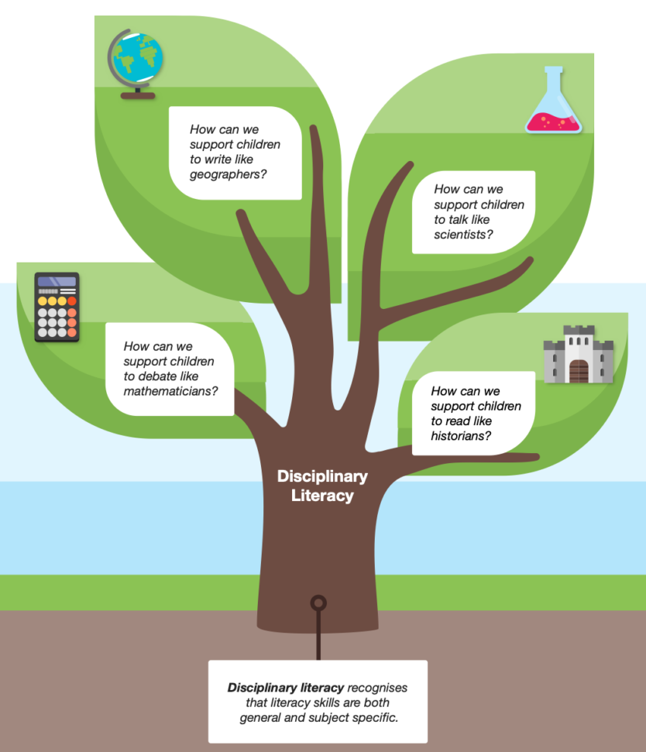
The EEF states that, “Disciplinary literacy is an approach to improving literacy across the curriculum. It recognises that literacy skills are both general and subject specific, emphasising the value of supporting teachers in every subject to teach students how to read, write and communicate effectively in their subjects.”
EEF - Improving Literacy in Secondary Schools
It is important to be clear that disciplinary literacy is not simply reading in other areas of the curriculum – it is the explicit teaching of how to read in each of these areas. The following blog gives clear examples of this: https://bedrocklearning.org/blog/disciplinary-literacy-what-it-is-and-why-its-important/
By recognising that the skills needed to read as a historian are different to those needed to read as a scientist, children can apply the relevant skills within the context of a specific field and become competent and successful learners.
This is a skill that will be developed throughout secondary school and the EEF refers to disciplinary literacy in their Improving Literacy in Secondary Schools Guidance Report; however, laying the foundations for these skills in primary school, will be hugely beneficial to pupils as they make the transition from KS2 to KS3.
We can do this by ensuring pupils are reading quality texts which support their learning in other areas of the curriculum. Primary school literacy needs to be rich and varied, with non-fiction texts embedded within it in a meaningful way to enrich pupils learning at the time and prepare them for KS2 and KS3.
Sometimes, as teachers, we can seek ways to avoid text in the wider curriculum. We know reading can be a barrier for some pupils so we use PowerPoint presentations, videos or allow children to research themselves online in order to present information. All of these approaches have a place in the classroom but we must be conscious to provide opportunities for teaching to also come through quality texts. If pupils are not exposed to learning in this way, how will they ever develop the skills and resilience needed to be successful at it?
Further Reading
EEF Guidance Report: Improving Literacy in Secondary Schools (Recommendation 1, pg 6-10) https://d2tic4wvo1iusb.cloudfront.net/eef-guidance-reports/literacy-ks3-ks4/EEF_KS3_KS4_LITERACY_GUIDANCE.pdf
Disciplinary Literacy: The Basics – Shanahan on Literacy https://www.shanahanonliteracy.com/blog/disciplinary-literacy-the-basics#sthash.CbaCGARs.lEcLR3dY.dpbs
Pre-complex texts
In order to prepare pupils for the complexity of the texts they will encounter in secondary school, not only in their English lessons but in all areas of the curriculum, Alex Quigley recommends the use of pre-complex texts. These are texts that contain simpler vocabulary and sentence structures than their KS3 or KS4 equivalents but with the same key issues and key knowledge. For example, Usbourne Illustrated Stories from Dickens introduces pupils to the classics of Charles Dickens in an accessible and age-appropriate way.
Using the signs of complexity from the ‘Arduous Eight’ (Closing the Reading Gap) allows teachers to mediate text difficulty, identify age-appropriate pre-complex texts and ensure progression across and within year groups. The more of the features below that can be found in a particular text, the more complex it is.
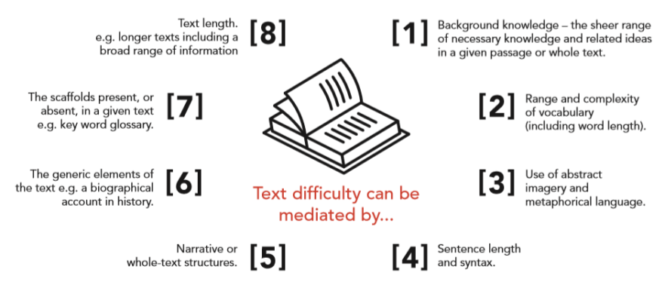
Closing the Reading Gap – Alex Quigley
See Alex Quigley’s blog for further information on the Arduous 8.
https://www.theconfidentteacher.com/2020/04/tricky-texts-and-the-arduous-eight/
5 Strategies for Reading Complex Texts
https://www.theconfidentteacher.com/2022/01/5-strategies-for-reading-complex-texts/
In this blog, Alex Quigley outlines 5 strategies for reading complex texts. These include ‘activating prior knowledge’ and ‘teaching keystone vocabulary’. Linking texts to work in other areas of the curriculum achieves both of these aims.
Quigley also explains how, “research shows that pupil interest in a topic can be an important motivator when it comes to persevering with reading very complex texts.” We found this to be the case in our schools. For example, a class had been on a school trip to Chester to learn about the Romans, and as part of this learned about gladiators. The following week, they practised their retrieval skills using a pre-complex text from non-fiction book about Romans. The enthusiasm and engagement with this text was much higher than in previous reading lessons and improved the accuracy of their answers to True and False questions.
Summary
Providing children with learning opportunities through high-quality non-fiction texts linked to wider curriculum learning has many benefits, including (but certainly not limited to):
- Enabling children to read, write and communicate effectively in all areas of the curriculum, not just English lessons.
- Increasing engagement and confidence in reading complex texts.
- Preparing children for the demands of the KS3/KS4 curriculum, especially the shift from reading mainly fiction at primary school to reading mainly non-fiction at secondary.

