Feelings:

Children to engage with how book, and/or characters make them feel.

Children to consider how character/s may feel at different points of the story.
Pupils can justify their ideas with evidence.
Question Stems:
KS1 | KS2 | More Able
Who is your favourite/ least favourite character and why? | What is your opinion of...? | How does the behaviour of X compare with Y...?
Explain why x makes y feel.... | Justify why x feels... | How does the author suggest that character x is feeling……?
Find the word in the text that tells you/ shows the character is..... | Find the word in the text that indicates the character is..... | How do you know, from the reactions of others, that the character is feeling....?
 | How does the author create the character’s feelings of …?
What lesson did……..learn? | What lesson did……..learn? | What lesson did……..learn?
How does…….change? | How does…….change? What evidence do you have? | How does…….change? What evidence do you have?
Tell me how…………..felt when……………happened? | Tell me how…………..felt when……………happened? What evidence do you have? | Tell me how…………..felt when……………happened? What evidence do you have?
What is the value of ……….to ………..? | What is the value of ……….to ………..? What evidence do you have? | What is the value of ……….to ………..? What evidence do you have?
Describe the feelings of ………………….. | Tell me some ways that the characters….. and …… are the same/different? Prove it. | Tell me some ways that the characters….. and …… are the same/different? Prove it.

Skim

Children read a text quickly to get a general idea of meaning.

It is important that children know that they don’t have to read every word when skim reading – they are reading to get the gist of the text.

Question Stems:
KS1 | KS2 | More Able
What is the key word in the question? Can you find it in the text? | What is the key word in the question? Can you find it in the text? | What is the key word in the question? Can you find it in the text?
Can you find the word……..? | Can you find a word that means the same as………..? | Can you find a word that means the same as………..?
Find the part of the story where……? | Find the part of the story where……? | Find the part of the story where……?
Look back at the text and skim for adjectives that mean……? | Look back at the text and skim for words that suggest that the character is feeling……? | Skim the text and summarise the gist/ key points
In which paragraph did the author use …………….? (punctuation ) | In which paragraph did the author use …………….? (punctuation )
Can you find a fact about……? (non-fiction text) | Can you find a fact about……? (non-fiction text) | Can you find a fact about……? (non-fiction text)
What sub-headings could you suggest for the paragraph you have just read? | What sub-headings could you suggest for the paragraph you have just read? | What sub-headings could you suggest for the paragraph you have just read?
The writer uses specific words/phrases to describe………….can you give examples? | The writer uses specific words/phrases to describe………….can you give examples? | The writer uses specific words/phrases to describe………….can you give examples?

Scan

Children read a text in order to find specific information e.g. names or places

Question Stems:
KS1 | KS2 | More Able
Can you find the name of ……? | Can you find the name of ……? | Can you find the name of ……?
Which word in paragraph ….. also means the same as……………? | Which word in paragraph ….. also means the same as……………? | Which word in paragraph ….. also means the same as……………?
Find the part of the story where……. | Find the part of the story where……. | Find the part of the story where…….
Find the fact in the story that means…… | Find the fact in the story that means…… | Find the fact in the story that means……
Find the example in the text that shows……. | Find the example in the text that shows……. | Find the example in the text that shows…….
Where in the text does it suggest…..? | Where in the text does it suggest…..? | Where in the text does it suggest…..?

PEE

Children to make a point (P), evidence it ( E) explain it in their own words (E )

Children to answer a question about a character or event in the text.
Children can justify their ideas with evidence.
Children can explain it in their own words.
Question Stems:
KS1 | KS2 | More Able
How does…….change? | How does…….change? What evidence do you have? | How does…….change? What evidence do you have?
Tell me how…………..felt when……………happened? | Tell me how…………..felt when……………happened? What evidence do you have? | Tell me how…………..felt when……………happened? What evidence do you have?
What is the value of ……….to ………..? | What is the value of ……….to ………..? What evidence do you have? | What is the value of ……….to ………..? What evidence do you have?
Describe the feelings of ………………….. | Tell me some ways that the characters….. and …… are the same/different? Prove it. | Tell me some ways that the characters….. and …… are the same/different? Prove it.
……..happens in the story. I know because in the text it says….. I think that ……………………. | One reason for……….an example of this is……………..this means that………………. | An alternative point of view is…….to support this idea is ………… consequently ……………
 | An important point is ……..for instance ………….this example shows that | In contrast……..a good illustration of this is……………furthermore………….

Inference:
An inference is “reading between the lines” to understand things not directly stated by the author. Inferences are based on information (clues) found in text as well as what is known from personal experience which relates to the passage being read.
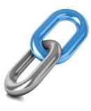
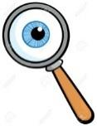
Text to self
Links
Inference
Text to world
Text to text
Question Stems:
KS1 | KS2 | More Able
Why does x feel/ sad/ happy/ etc. ? | Why does x feel embarrassed/  /disappointed/ revengeful etc.? | What is the overall theme of ________ ?
Why do you think x tricked  Y? | How does X really feel when he says ‘It’s fine.’? | What is the moral of the story?
From the title/heading, what you can predict? | What evidence tell us that x doesn’t want to go home? | Based on your readings, what can you conclude about ________ ?
Why do you think …..? | What do you think happened to cause the broken window? (where details are not given explicitly and retrieval skills can't be used) | What was the author's point of view?
How do you know that …..? | Why does the author use the word …..? What is he implying? | What generalization can you make from this information?
What can you infer from the picture what will happen next? | What message is the author trying to give? | Propose a solution to the main character’s problem _______
The dog barked when he saw the bushy tail running up the trunk?  What had upset the dog? | Can you infer the meaning of … | What words build the impression of …….
The cat meowed because she was hungry. What did she want? | What probably caused ….? | How does the tone of the narrative change?  Use supporting evidence from the text.
Sally’s snack was melting in the heat. What was she eating? | Which line/phrase from the text supports the idea that the man has given up? | How has the author used, e.g. adjectives, to make this character funny?
The boys stepped on the sandcastles. Where were they? | Why did the travelling fair children not attend school? | How were the purposes of the texts different?

Summarise:
Effective readers spot important parts of a text and connect them together to build meaning.
Linking the most important ideas with inferred views and thoughts is synthesis.
Question Stems:
KS1 | KS2 | More Able
Can you order the events/ information?  (provide statements to be discussed) | Can you summarise ________ (event in the text)? | Can you summarise the character’s attitude/ the writer’s opinion towards…..
Which statement is the best description of the whole text? | Which of the following would be the most suitable summary for the whole text? | Put these summaries in the order they appear in the story/ text.
Which sentence is the best summary for the whole of paragraph/ chapter… | Which statement is the best summary for the whole of paragraph/ chapter… | Which statement could you leave out of a summary explaining how the men were rescued?
Which word best describe the setting? | Which sentence best describes the character/ setting etc? | Write a short summary of the setting.
Which sentence best describes……? | Which sentence best describes how David creates his illusions? | Make a summary of David Copperfield’s most spectacular illusions?
What is the poem about?  (provide statements) | What is the main message of the poem?  (provide statements) | What do you consider the main message of the poem to be?
 | Summarise what Andrew Bell says under the subheading ‘ Clashes at public meeting’. | Write one sentence that summarises his thoughts.
 | How can the section ‘Traditional Escapes’ be summarised?  (provide statements) | How can the section ‘Traditional Escapes’ be summarised?
 | Which of these sentences is the main idea? | Read from……..What is the main idea of section?

Further ideas:

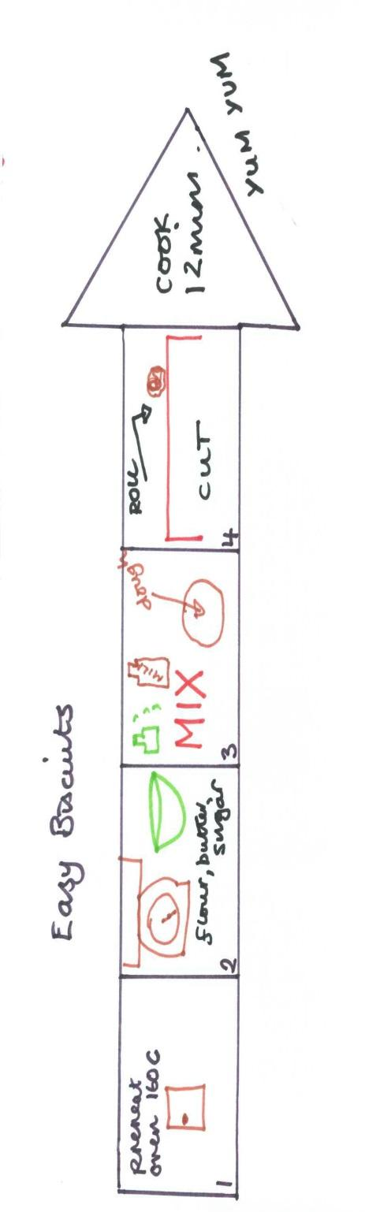
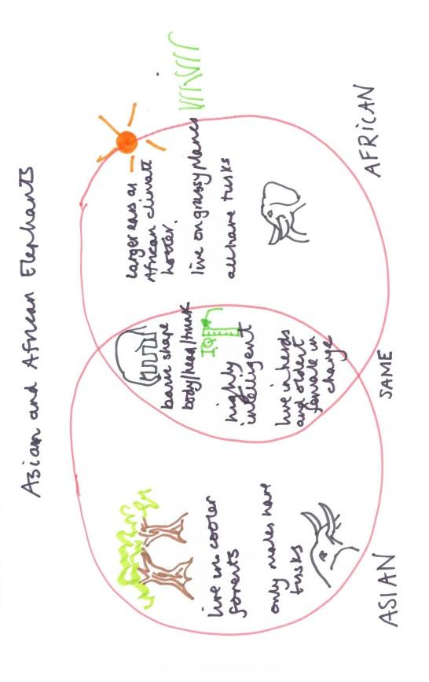
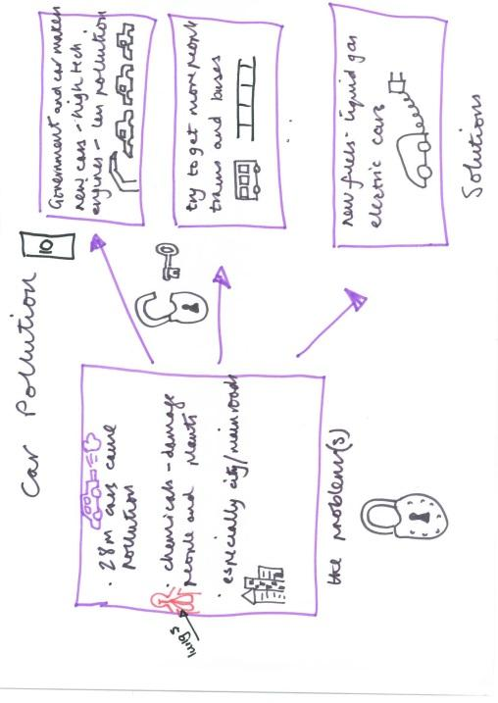
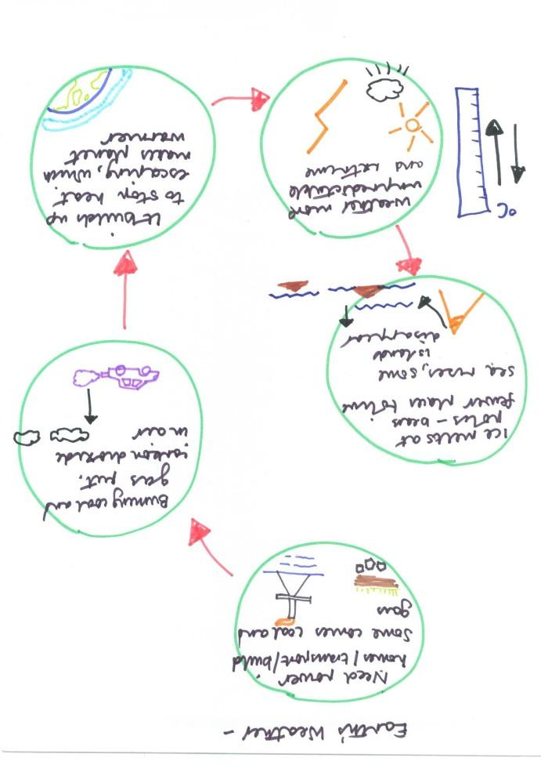
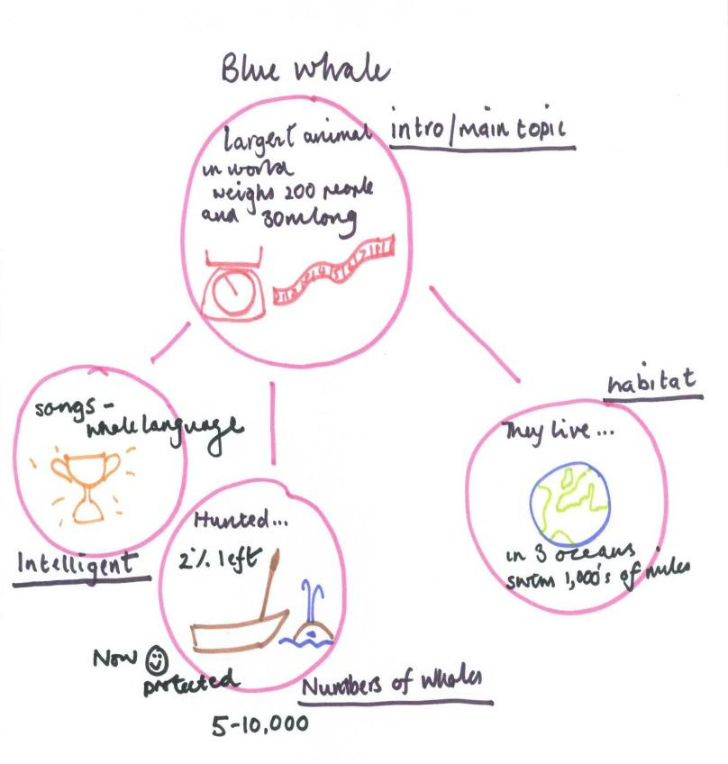
Cause and Effect
Description Text
Sequence Text
Compare and Contrast
Problems and solution

The jigsaw can be used as a tool to show how important words can link together to explain the main idea.

Question:
Children should be encouraged to question about stories and texts. Good readers do this naturally.
The Question Matrix is designed to support children to develop question stems to support their thinking.
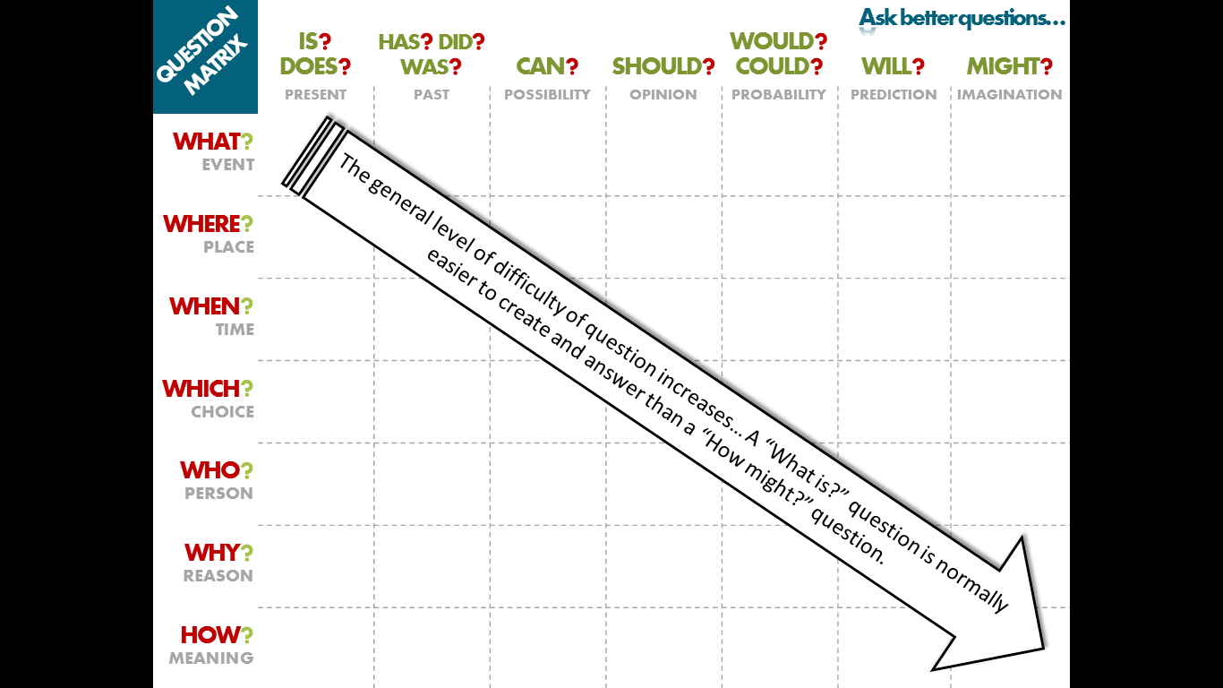

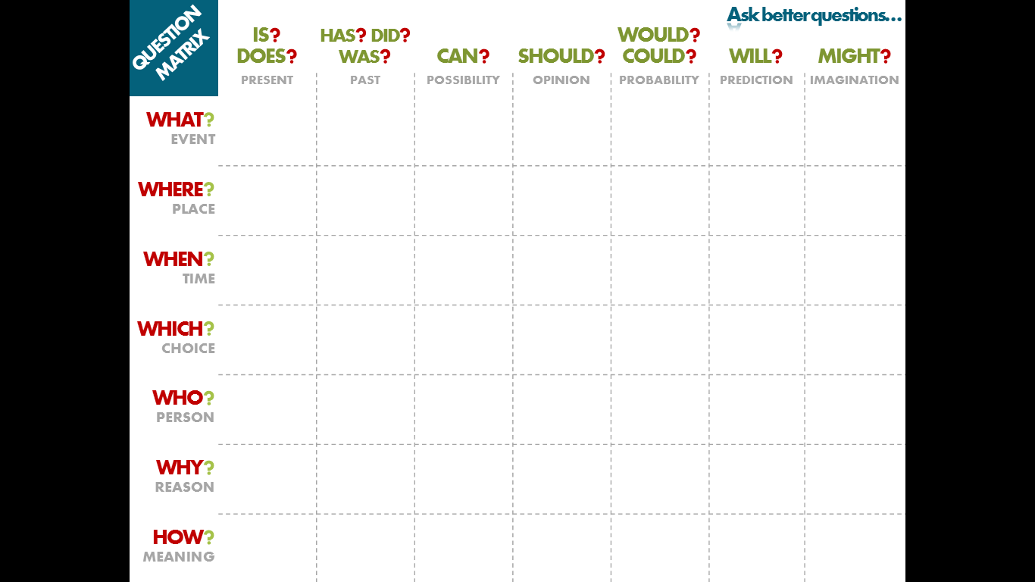
Clarify

Children to be able to explain what they have read

Question Stems:
KS1 | KS2 | More Able
What has happened so far? | Can you summarise what you have read? | Can you summarise what you have read?
Tell me what you have read | Can you explain what you have read? | Can you explain what you have read?
Read this sentence again, what do you now think it means? | Re read _______ has your understanding changed? | Re read _______ has your understanding changed?
What do think the word _______ means? | What do think the word _______ means? | What do think the word _______ means?

Predict:

Children to predict what might happen from details stated and implied

It is important that children make predictions based on what they have read.

Question Stems:
KS1 | KS2 | More Able
What do you think will happen next? | What do you think will happen next? | What do you think will happen next?
What do you think would happen if -----? | What do you think would happen if -----? | How would the characters react if _______ happened?
What do you think will happen to ____? Why do you think this? | Based on what you have read, what does the last paragraph suggest might happen next? | Based on what you have read, what does the last paragraph suggest might happen next? What made you come to that conclusion?
What do you think this character may do next? | Why did the author choose this setting? Will that influence how the story develops? | Why did the author choose this setting? Will that influence how the story develops?
Where do you think_____? | Choose one character from the book and predict how they will behave/react? | Choose one character from the book and predict how they will behave/react?
Tell me another way that this could end/continue? | Can you predict several possible outcomes? | Can you predict several possible outcomes and explain your answer?
What do you think happened after the story ended? | If there was a sequel, what might happen? What do you think of this? | If there was a sequel, what might happen? What do you think of this?
How do you think the story might end? | How do you think the story might end? | Do you want to change your prediction now that you have read more of the story?
What could go wrong for this character? | What challenges do you think this character might face? | What challenges do you think this character might face? How will they react?

